**NE HEMS PTS Checklist and Criteria Workflow**

|  |  |  |  |  |
| --- | --- | --- | --- | --- |
| **Date & time of PTS request received:** |  |  |  |  |
|  |  |  |  |  |
| **Details:** |  | **YES** | **NO** | **COMMENT** |
| **Name of requesting transfer doctor & medical number** | **VIP transport** |  |  |  |
|  |  |  |  |  |
| **Transferring hospital & phone number** | **Patient meets criteria in exclusion criteria** |  |  | *If yes please specify:* |
|  |  |  |  |  |
| **Name of receiving transfer doctor & medical number** | **Medical report received from transferring facility to ensure patient stability for flight** |  |  |  |
|  |  |  |  |  |
| **Receiving hospital & phone number** | **Receiving hospital contacted and bed available for acceptance of patient** |  |  |  |
|  |  |  |  |  |
|  | **Patient requires incubator for transport** |  |  | *If yes - hospital must provide incubator (o2 will be provided if needed but power will not - battery must be of sufficient charge for flight time)* |
| **NA staff ID & name:** |  |  |  |  |
| **Time of completion:** | **ACC contacted for CAD number** |  |  | *CAD number:* |
|  |  |  |  |  |
|  | **Confirmed that medical escort will travel whom has ability to clinically manage patient** |  |  |  |
|  |  |  |  |  |
|  | **Discussed and confirmed with airwing operations** |  |  | *Name:* |
|  |  |  |  |  |
|  | **ETA timings to transferring and receiving facility conveyed with requirement for ambulance to be on standby and helipad secured** |  |  |  |

**NE HEMS PTS Checklist & Criteria Workflow**

**Exclusion criteria:**

1. Patients who have underwent major surgery within the last 10 days with serious complications

2. Unstable patients who require urgent procedures like a laparotomy.

3. Patients with an active untreated communicable disease that put the crews at risk.

4. Patients with unsplinted fractures.

5. Paediatric patients with a high fever of 40 degrees Celsius or above unless controlled.

6. Patients with active and uncontrolled traumatic bleeding.

7. Patient who are of sound mind that refuse transfer.

8. Unstabilized critical case

9. Sending facility has the same capability to manage the patient as the receiving facility.

10. Activation process for ground ambulance is faster than the air ambulance.

Author: Michael Oconnor

Version & Date Last Modified: November 2020 Version: 1

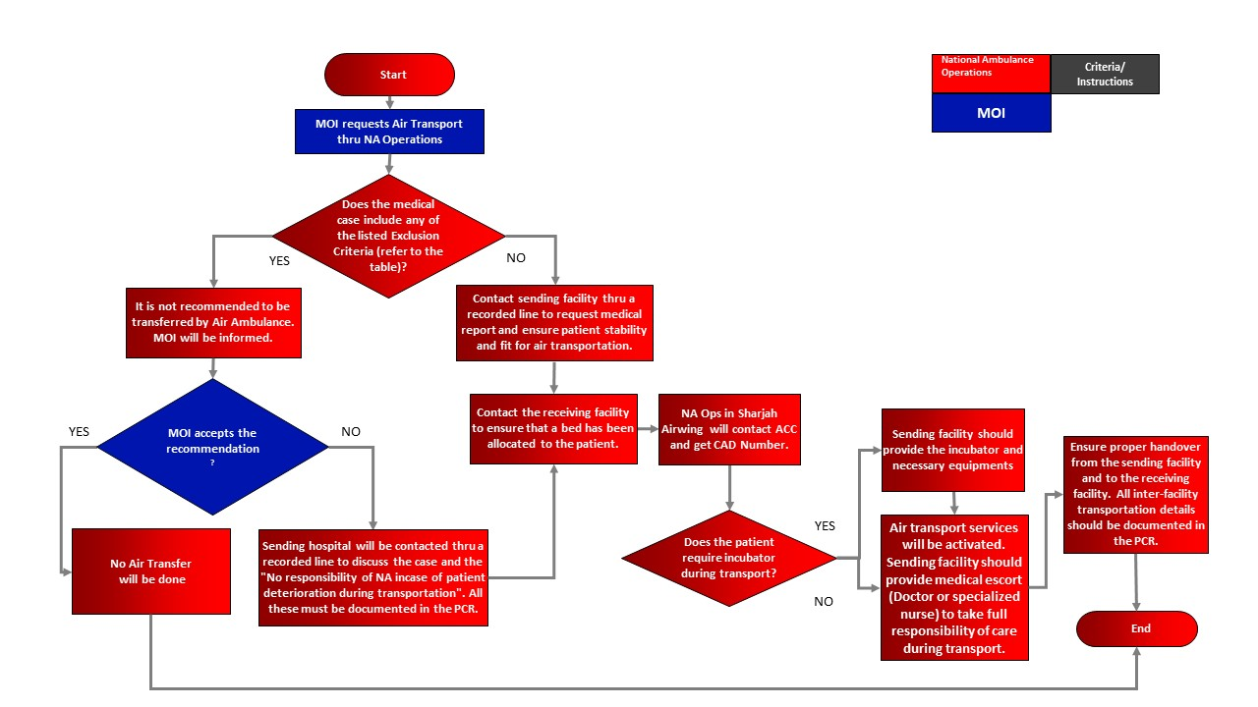

**General Instructions**

1. Only 1 patient for PTS

2. No accompanying family members (pediatric cases??)

3.All cases should be escorted with a clinician from the sending facility. This clinican accompanying the patient is primarily responsible for all medical care, assessment and treatment rendered to the patient.

4. In case if 2 clinicians from sending facility are required, 1 NA clinician will be removed from flight list.

5. Patient must be packaged for flight

6. Pilot will have the final decision to fly or not or if there is a required flying condition. Maybe required to divert due to weather etc.

7. Heli pad must be secured at the sending/ receiving facilities and ambulance arranged by them to take patient to / from heli pad.